Documentation: Installation of Kali Linux on Oracle VirtualBox

Project Title
Installation of Kali Linux as a Guest Operating System on Oracle VM VirtualBox

Date
January 01, 2026

Objective
To install Kali Linux (a penetration testing and ethical hacking Linux distribution) inside Oracle VM VirtualBox on a Windows host machine, using the official installer ISO image. This setup allows safe and isolated use of Kali Linux without affecting the host system.

## Software Versions Used
- Host OS Windows ( Windows 10 pro)
- Virtualization Software: Oracle VM VirtualBox (version shown as 7.2.4-170995~Win)

- Kali Linux Version: 2025.4 (installer image: kali-linux-2025.4-installer-amd64.iso)

Step-by-Step Installation Process

Step 1: Download and Install Oracle VirtualBox

1. Open the web browser (Microsoft Edge or Chrome).
2. Search for "virtualbox" on Bing or directly visit https://www.virtualbox.org.
3. Navigate to the Downloads section.
4. Download the latest VirtualBox installer for Windows hosts (VirtualBox-7.2.4-170995-Win.exe).
5. Run the installer and follow the on-screen instructions to complete the installation.

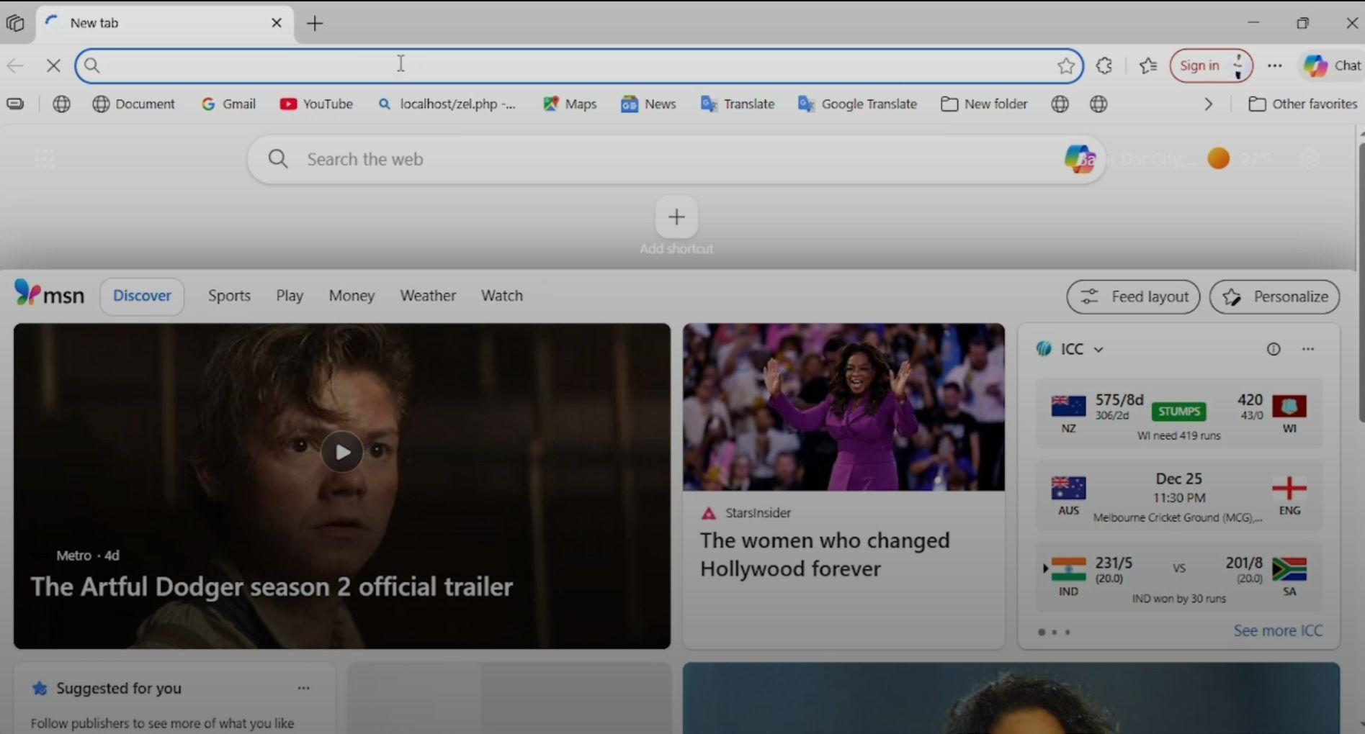
Image ID: 0 shows a new tab open.

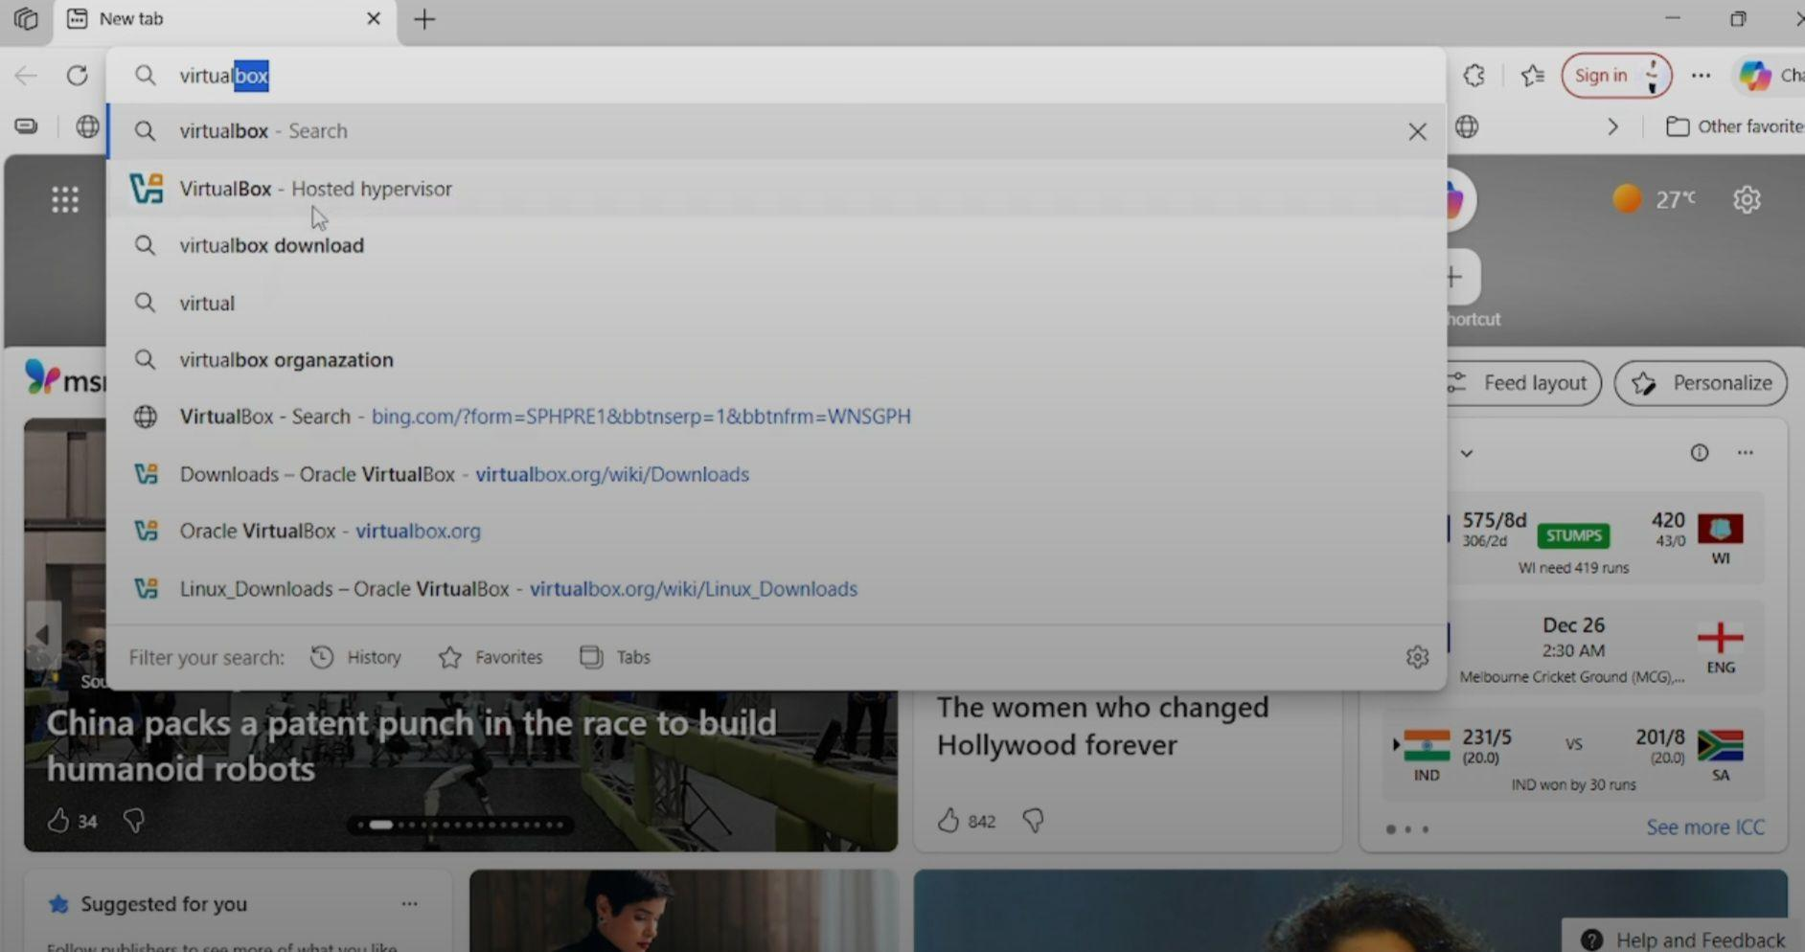
- Image ID: 1 and 2 show searching for Virtual box
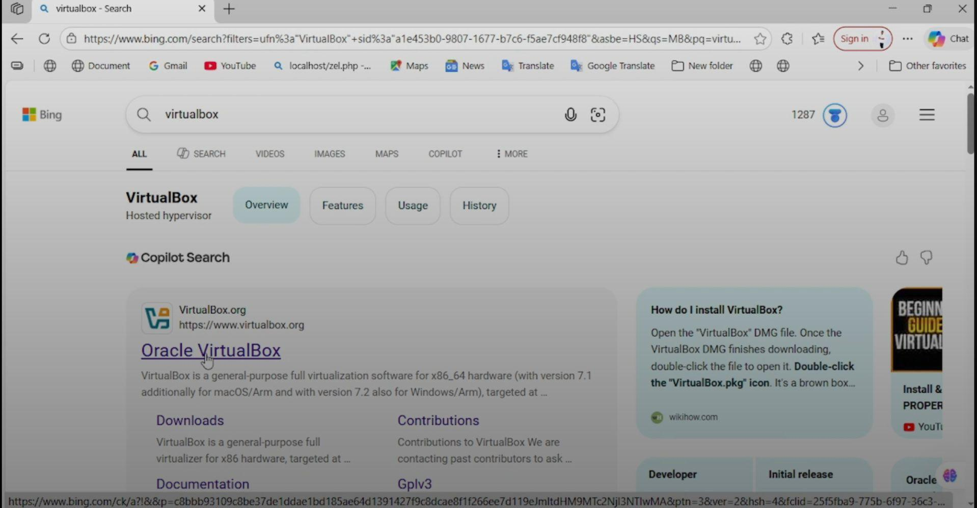

- Image ID: 2 show start download virtual box

Step 2: Download Kali Linux Installer ISO
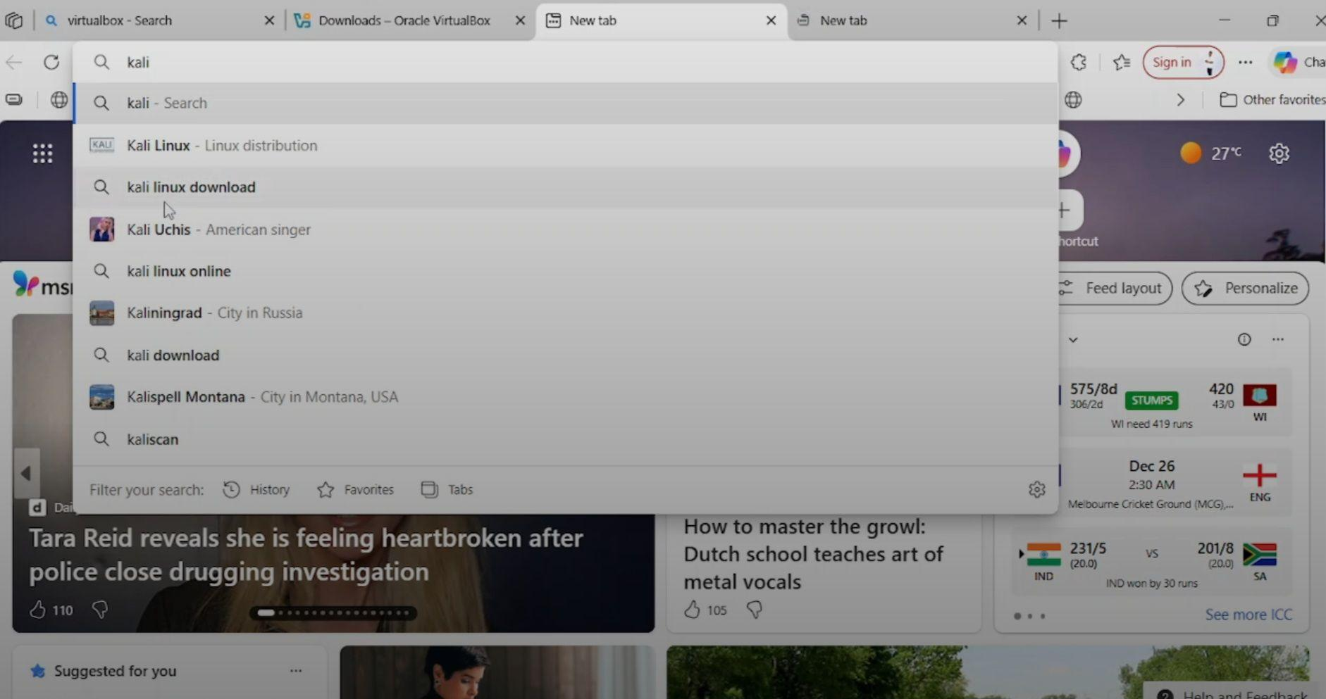
Image ID: 3 show searching for "kali linux download".

1. In the browser, search for "kali linux download".
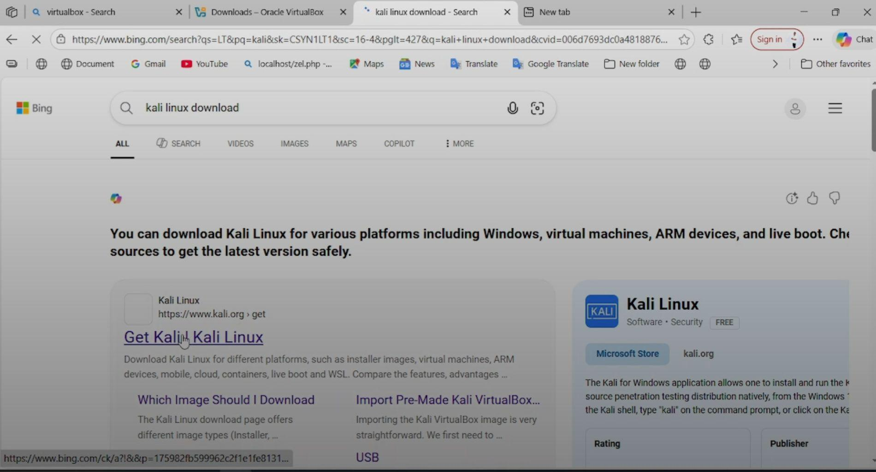
Image ID: 4 show searching for "kali linux download".
2. Visit the official Kali Linux website: https://www.kali.org/get-kali/.
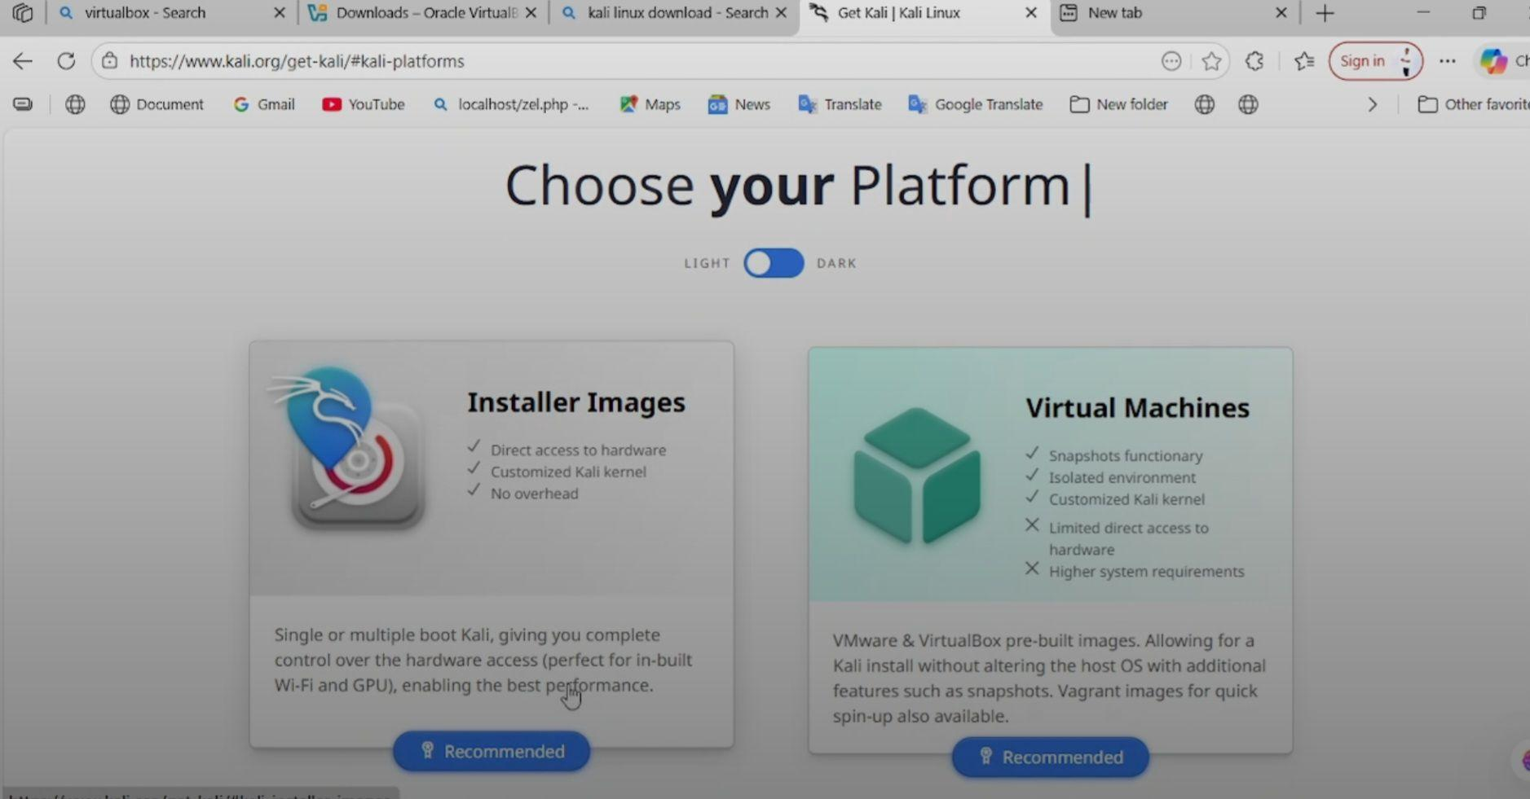
Image ID: 5 shows navigating to https://www.kali.org/get-kali/#kali-platforms.
3. Under "Installer Images", select the recommended x86_64 (64-bit) architecture.
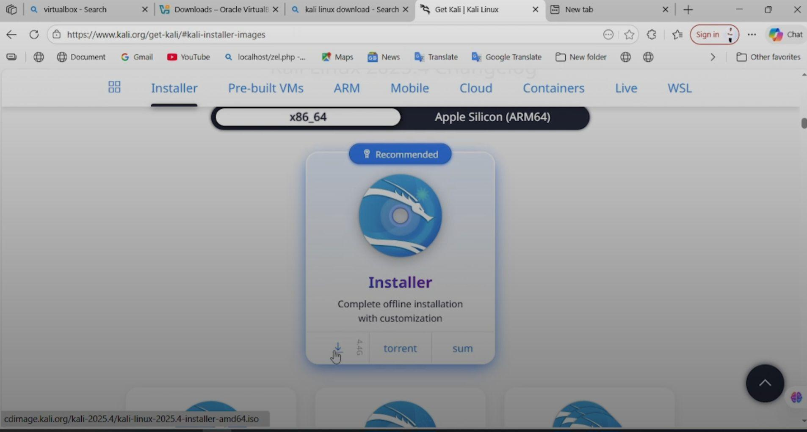
Image ID: 6 shows the Installer Images section with the x86_64 option selected.
4. Download the Installer ISO file (kali-linux-2025.4-installer-amd64.iso).
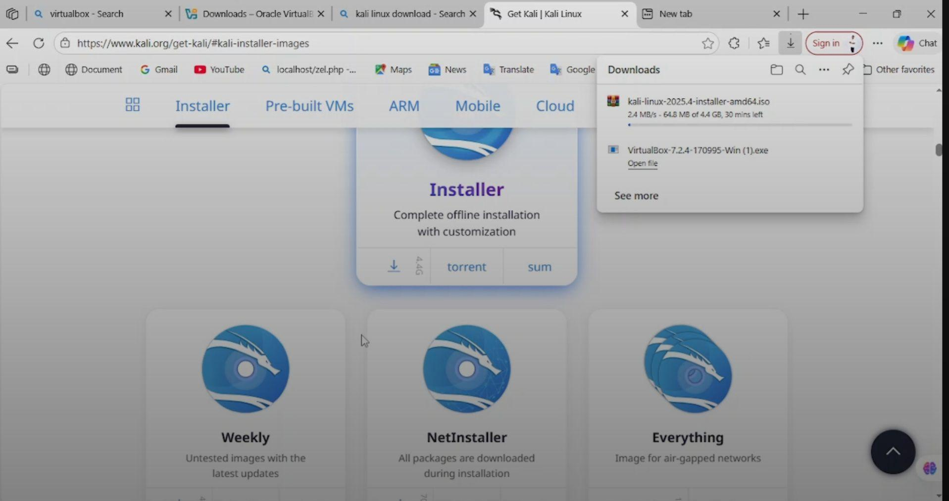
Image ID: 7 shows the download starting (kali-linux-2025.4-installer-amd64.iso, size ~4.4 GB)

Alternative note: For quicker setup, pre-built VirtualBox images are available, but this project uses the installer method for full customization.

Step 3: Create a New Virtual Machine in VirtualBox
1. Open Oracle VM VirtualBox Manager.
2. Click Newto create a new virtual machine.
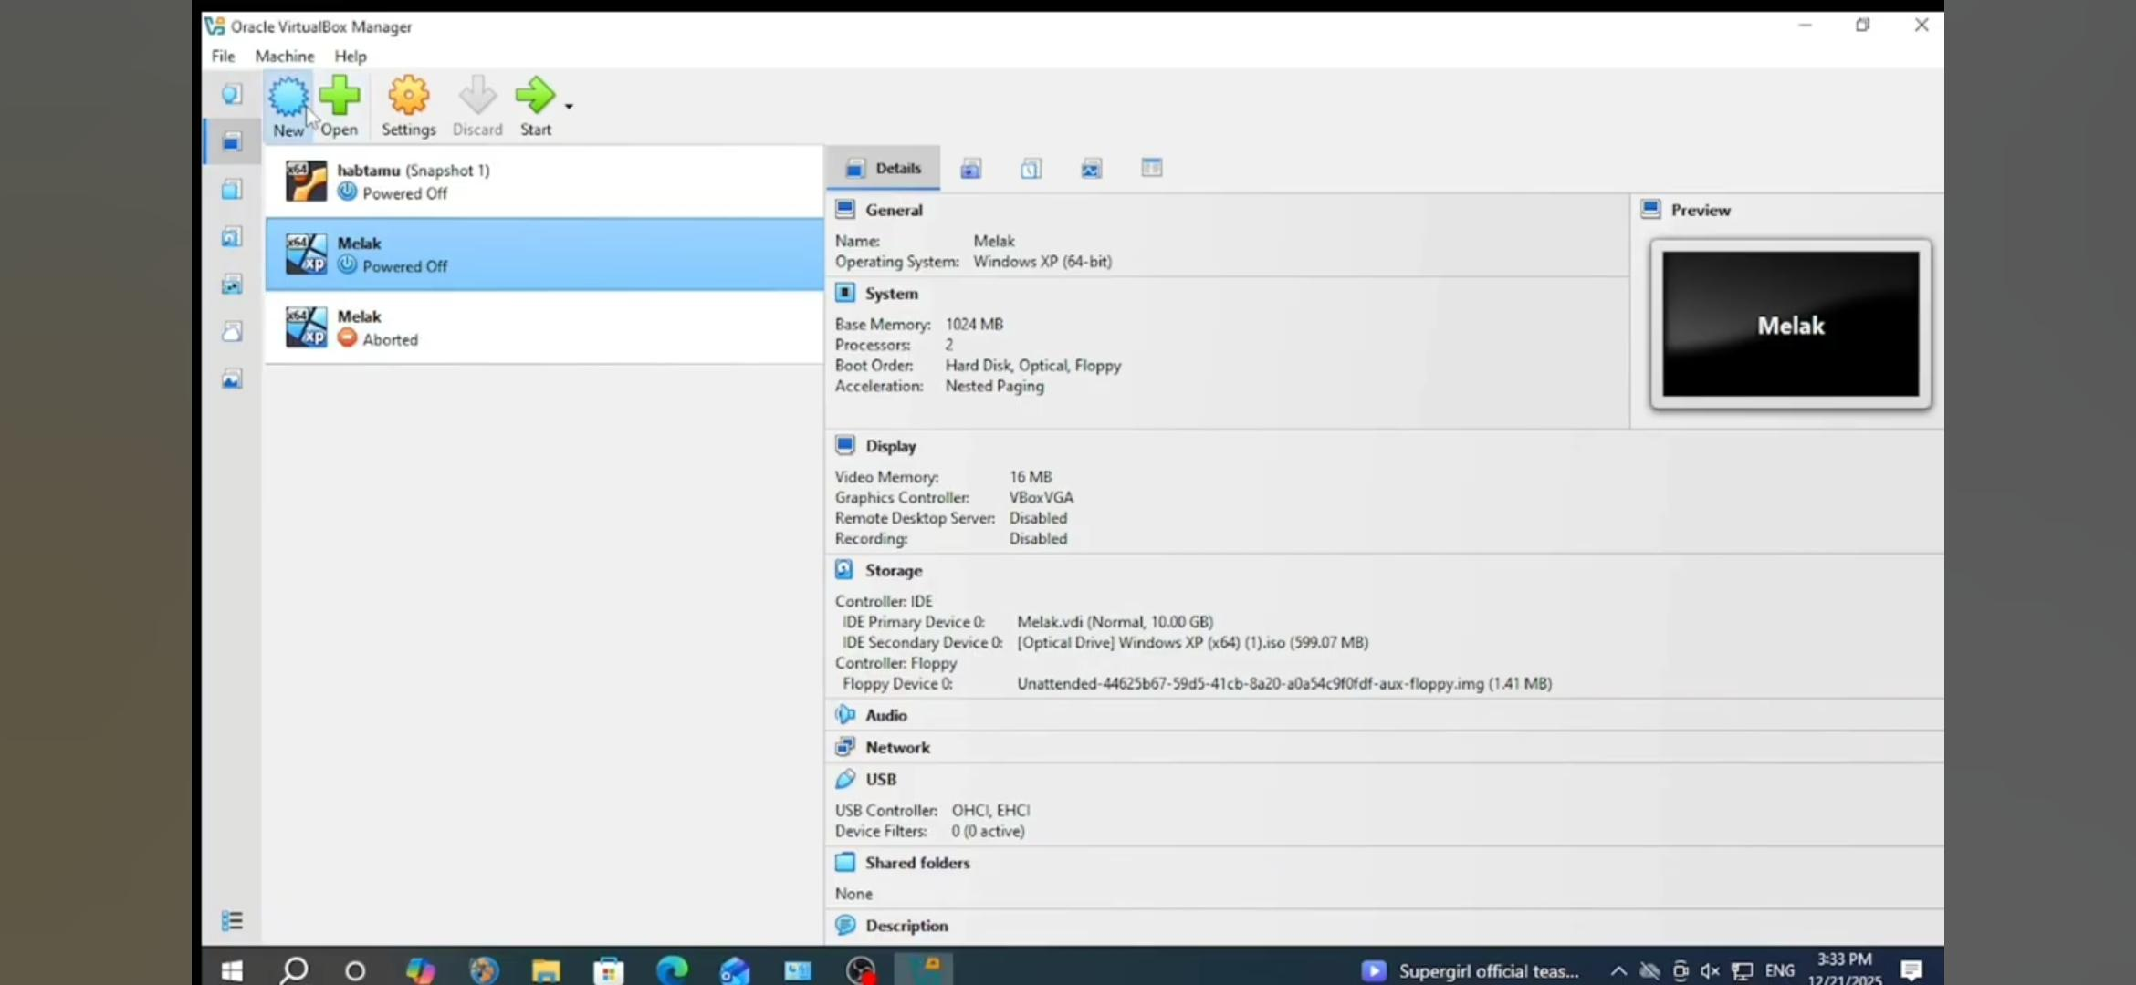
Image ID 8: shows clicking new
3. Name: Kali Linux .
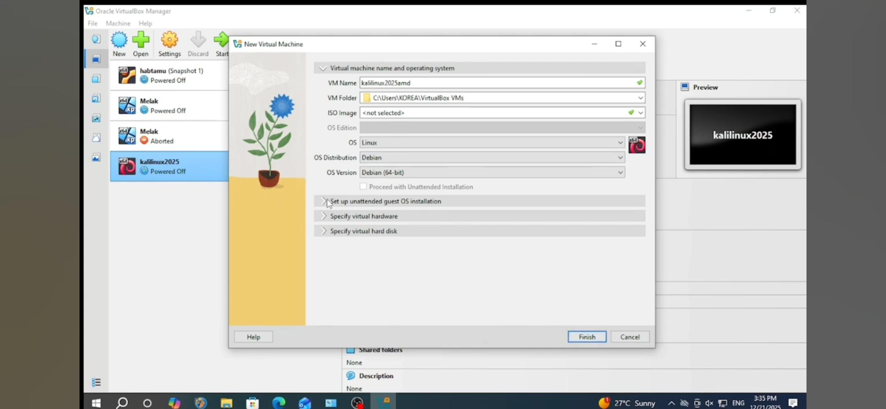
Image ID 9: shows naming Kali Linux, Debian and Debian 64 bit
4. Folder: Default or custom location.
5. Type: Linux.
6. Version: Debian (64-bit).

7. ISO Image: Browse and select the downloaded kali-linux-2025.4-installer-amd64.iso.
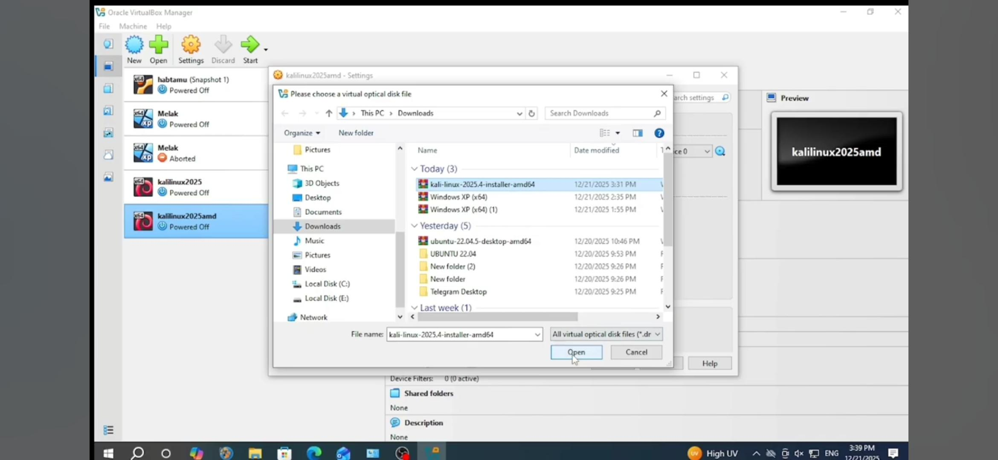

8. Allocate resources:
- Memory (RAM): At least 2048 MB (recommended 4096 MB or more).
- Processors: 2 or more cores.
- Hard Disk: Create a virtual hard disk (VDI, dynamically allocated, at least 20-50 GB).
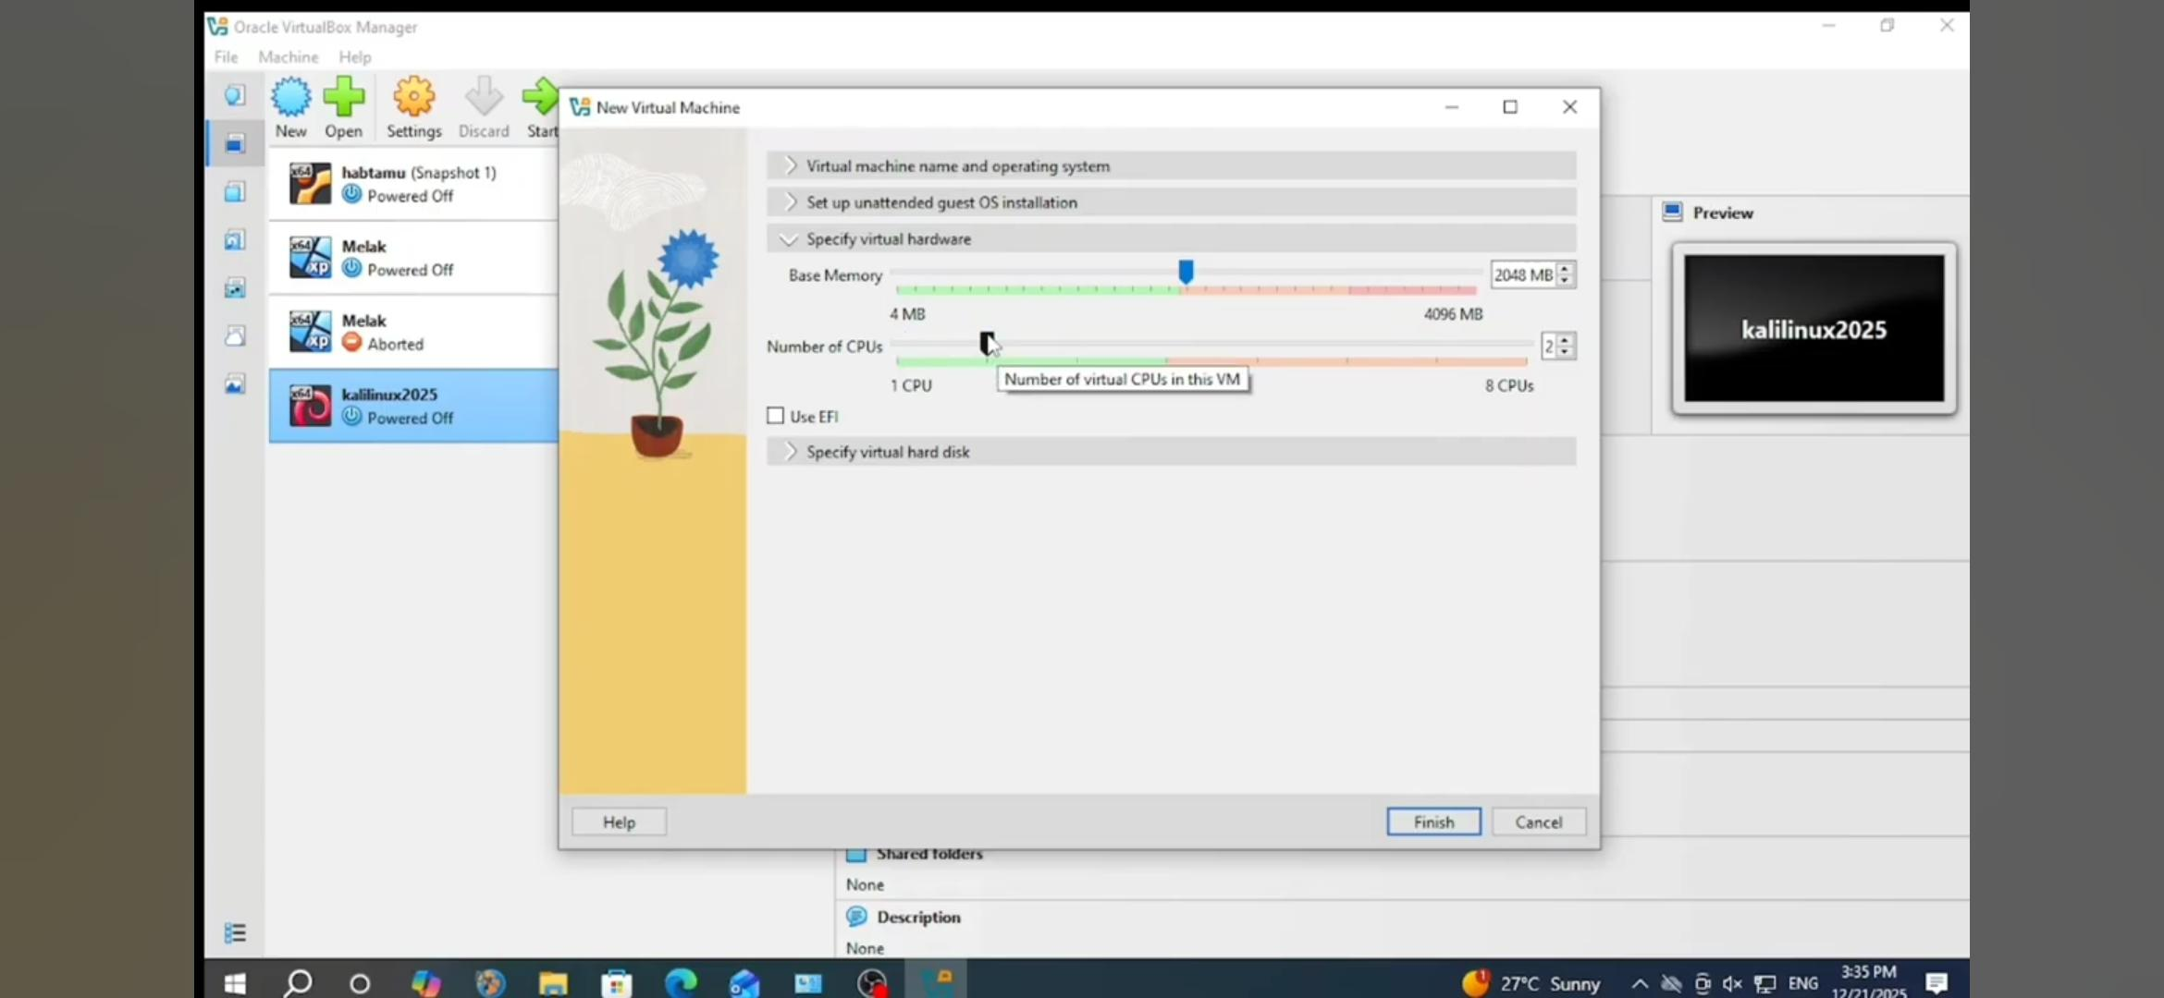
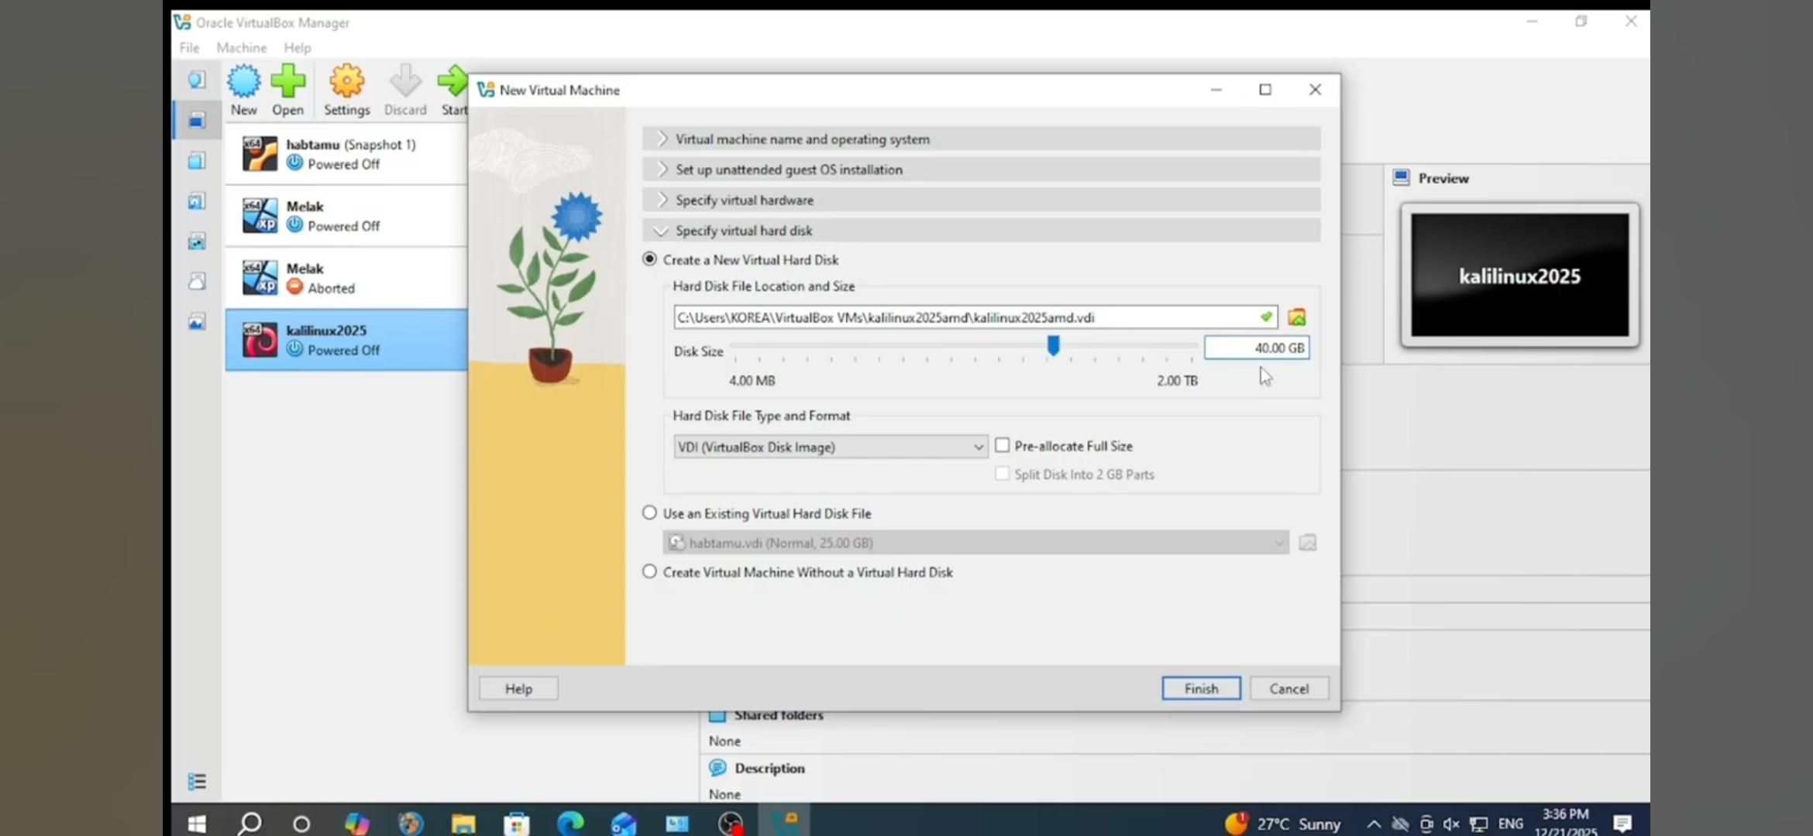
9. Finish creation and adjust settings if needed (e.g., enable EFI if required, increase video memory).

Step 4: Install Kali Linux
1. Select the new VM and click Start.
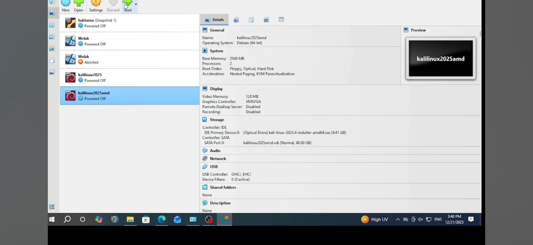
2. The VM boots from the ISO.
3. Select Graphical Install (recommended for beginners).
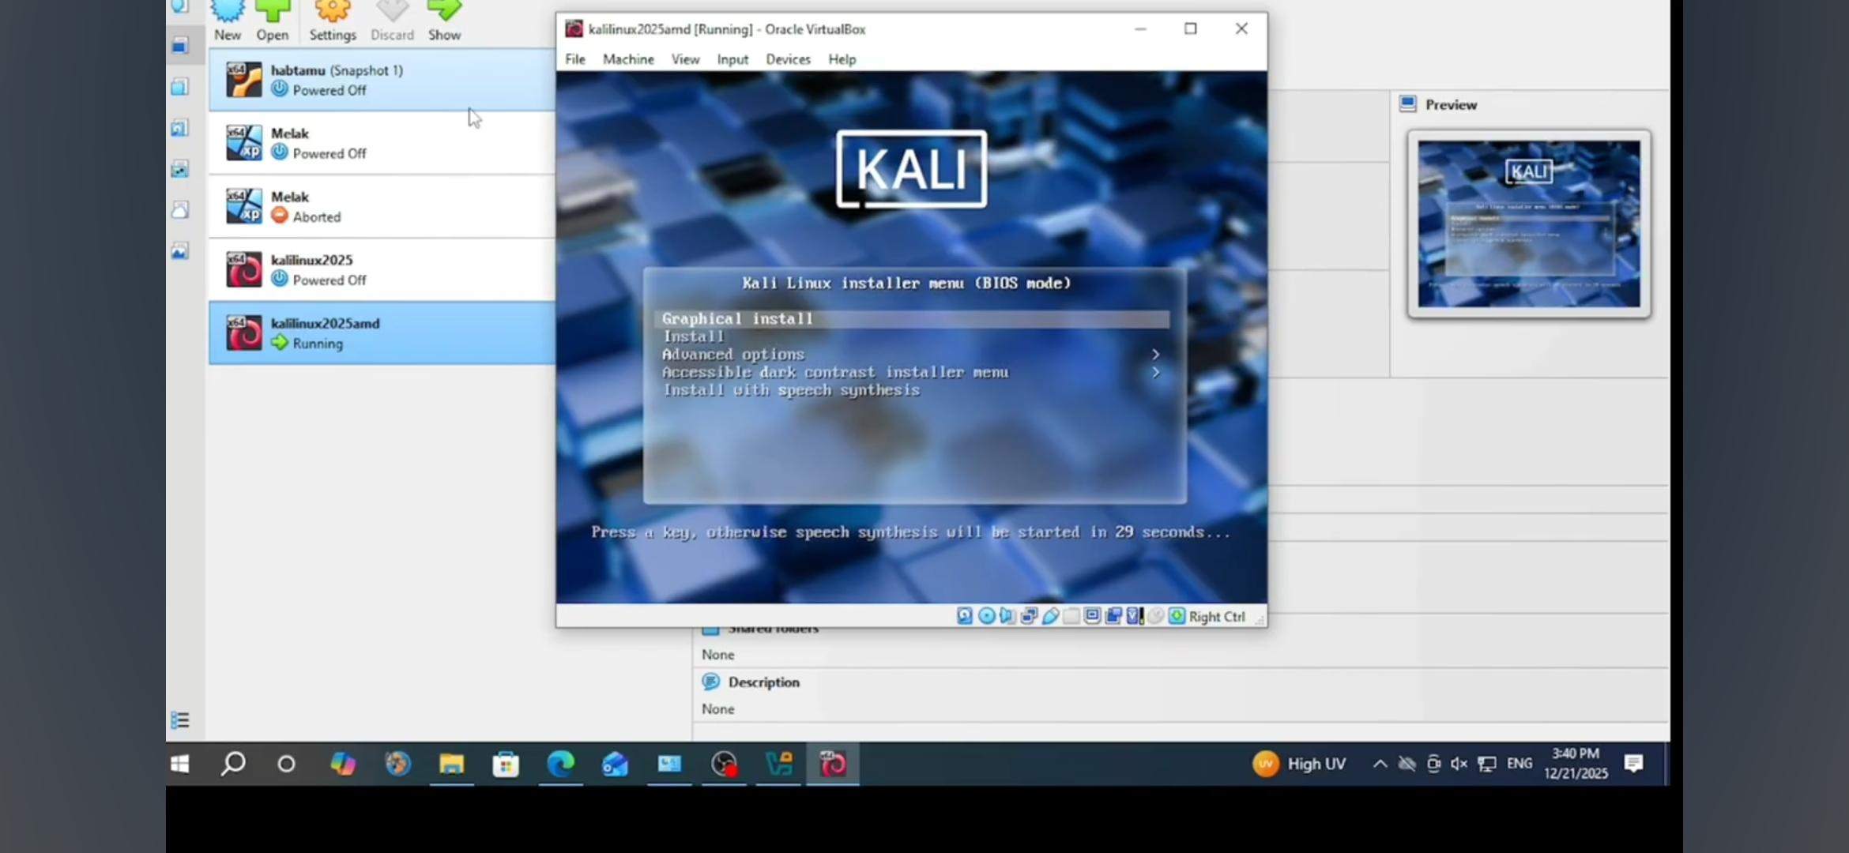
4. Follow the installer prompts:
- Language, location, keyboard layout.
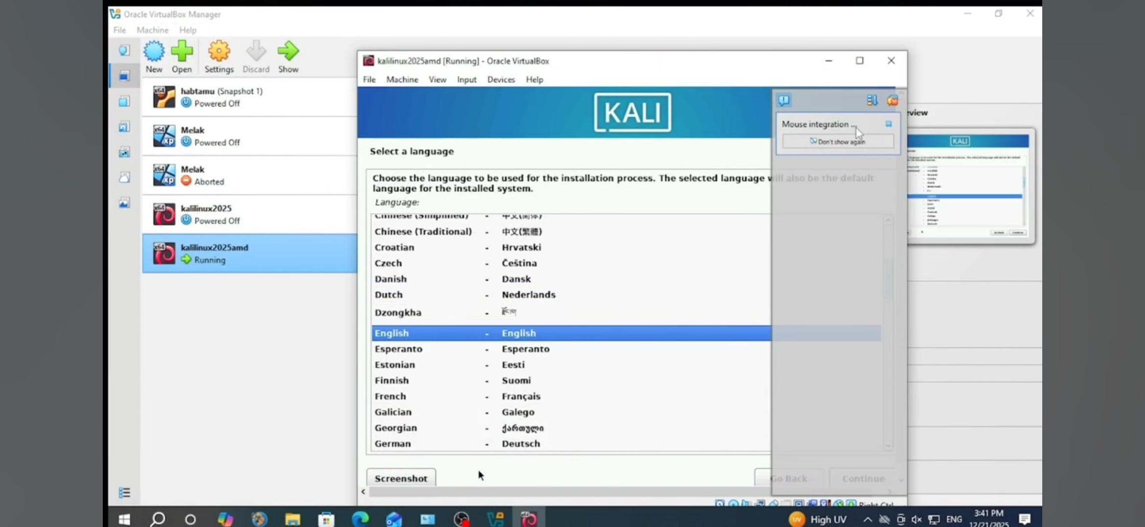
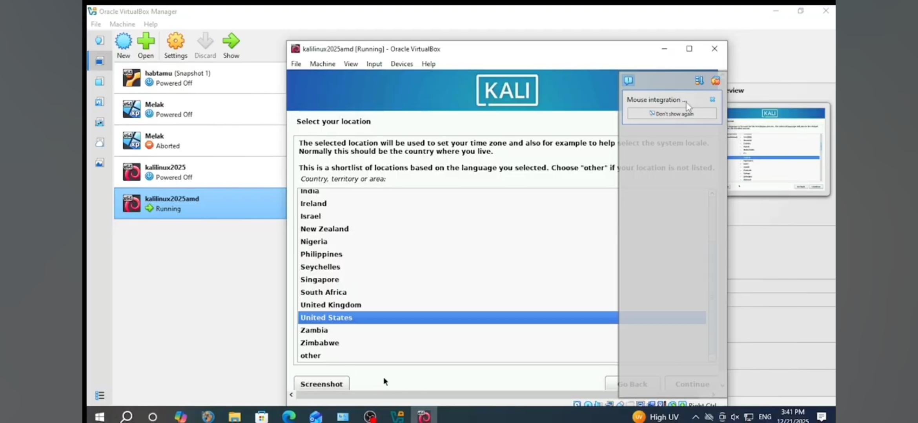
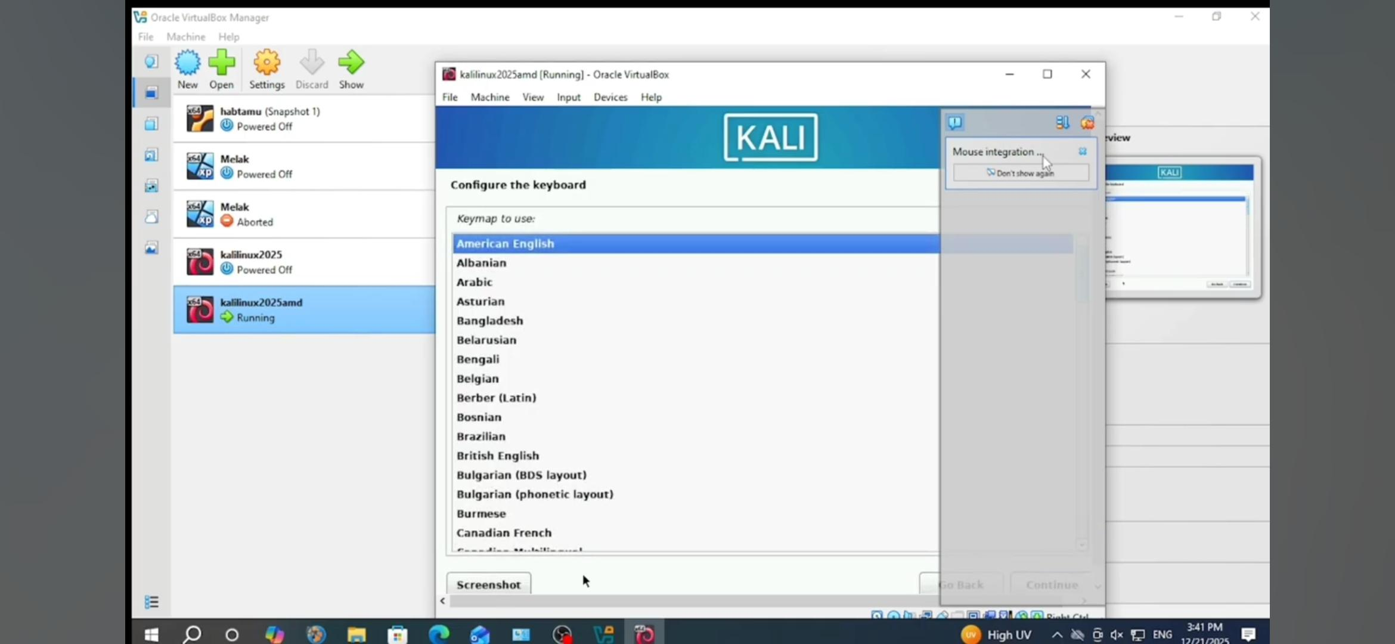
- Hostname and domain.
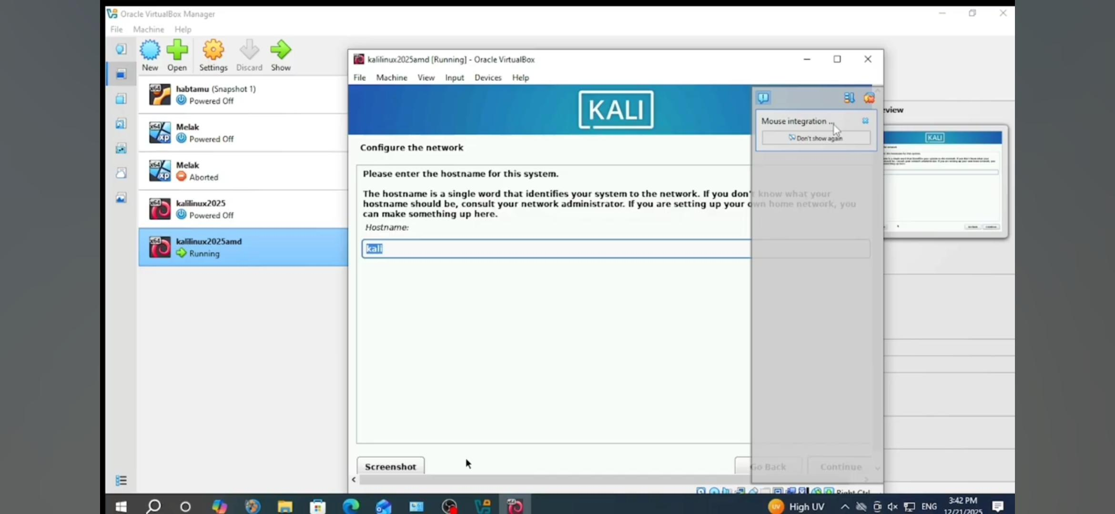
- Set root password and create a user account.
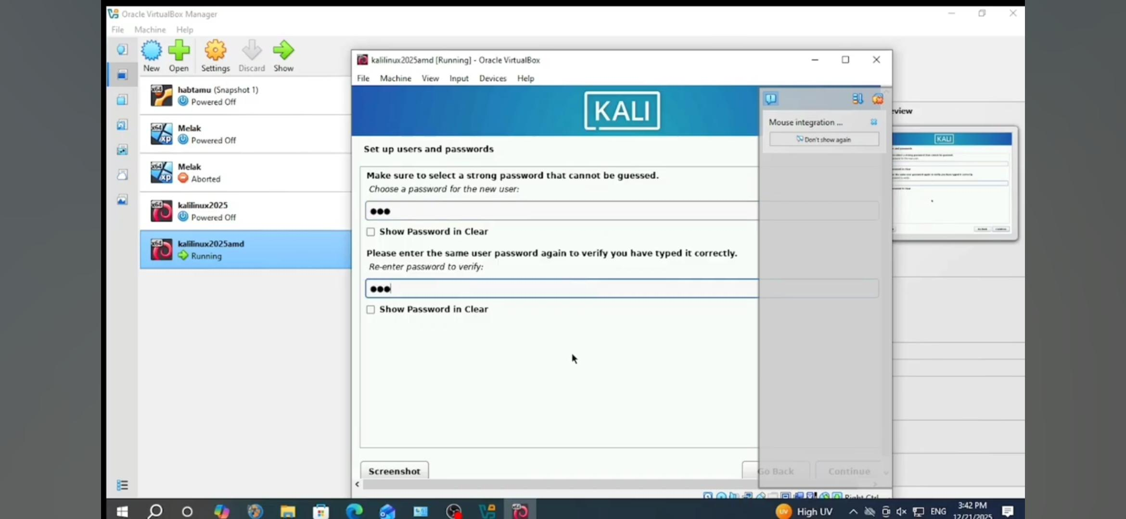
- Partition the disk (use entire disk for simplicity).
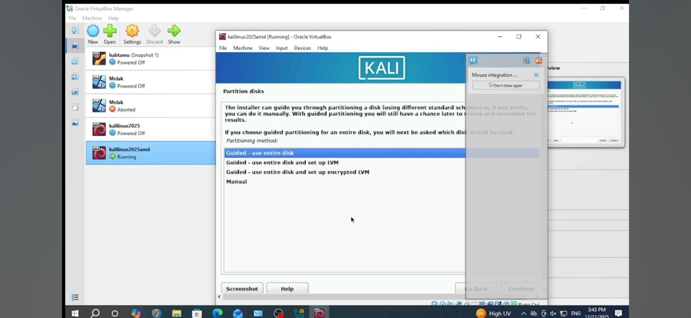
- Select desktop environment (default XFCE or others).
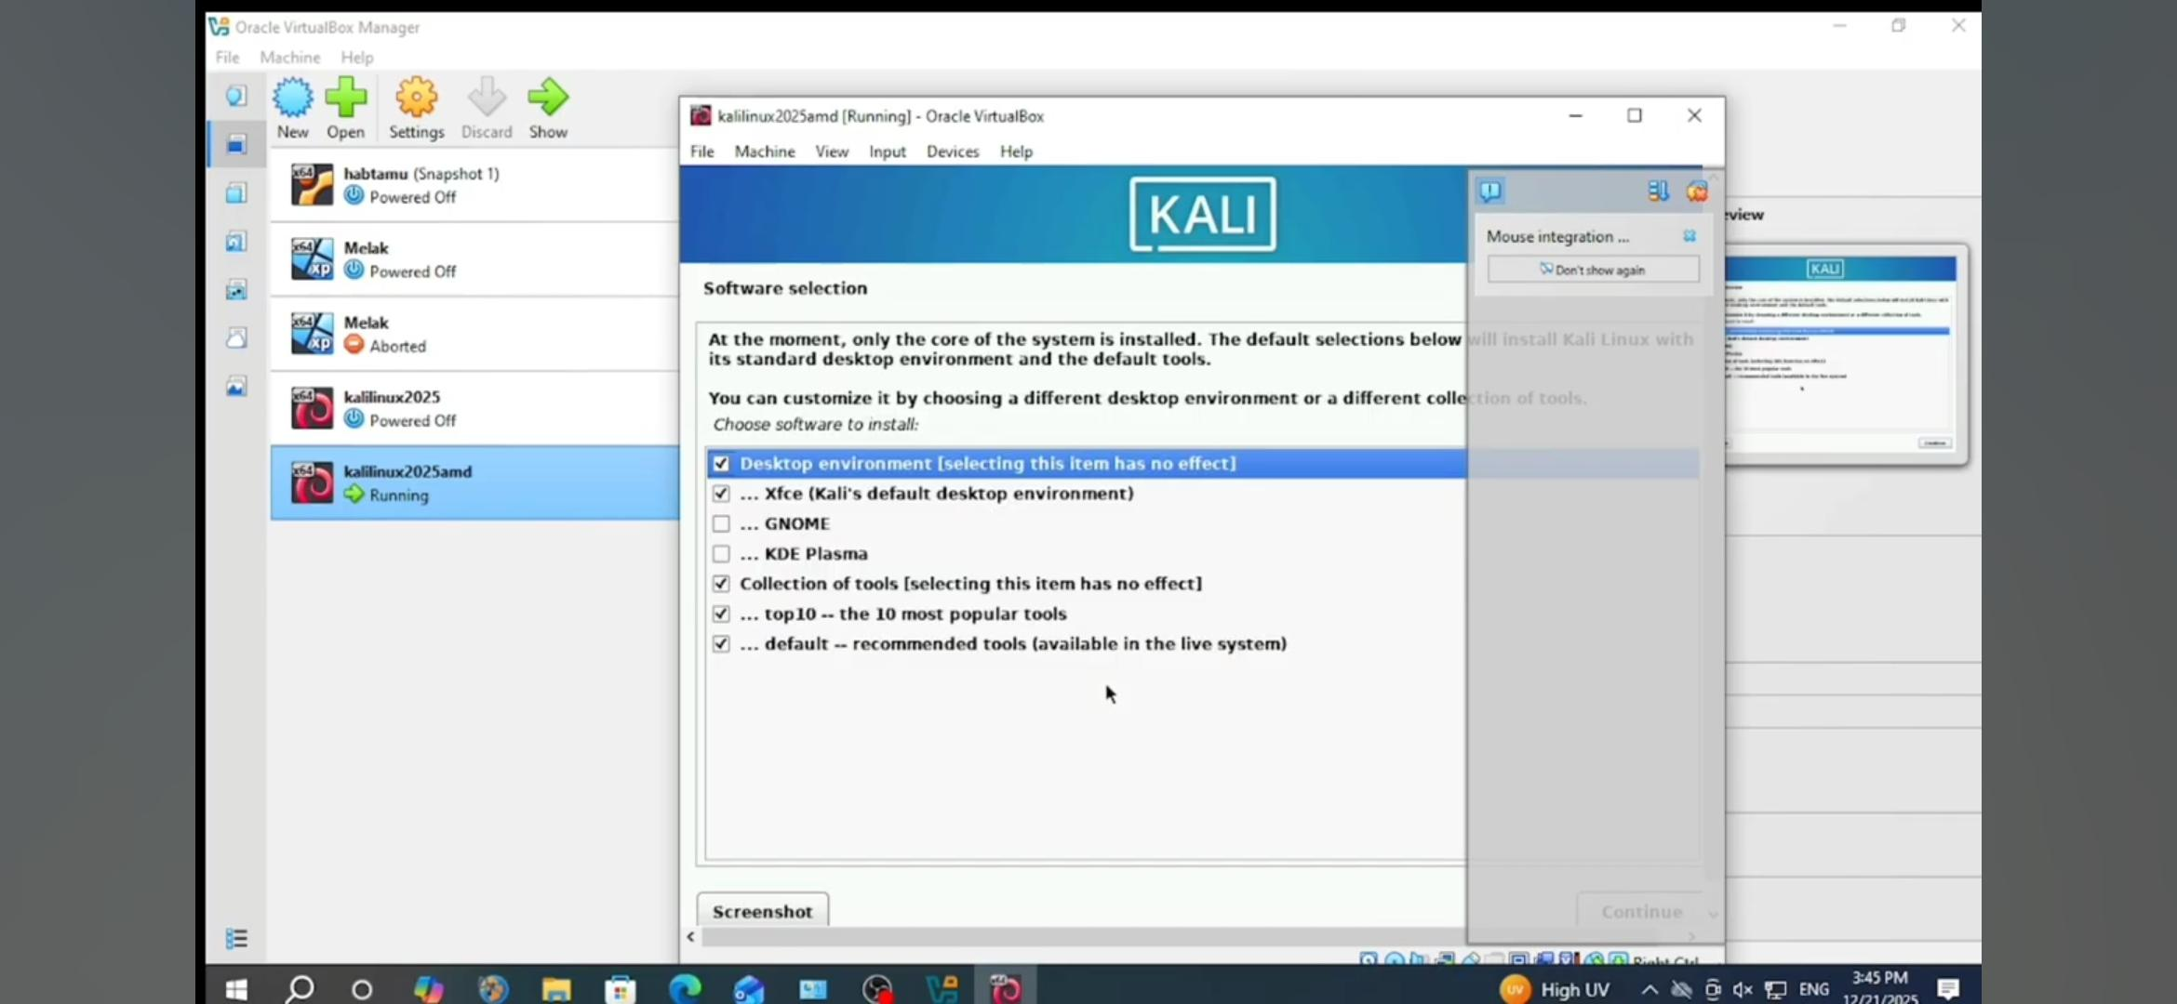
- Install GRUB bootloader.
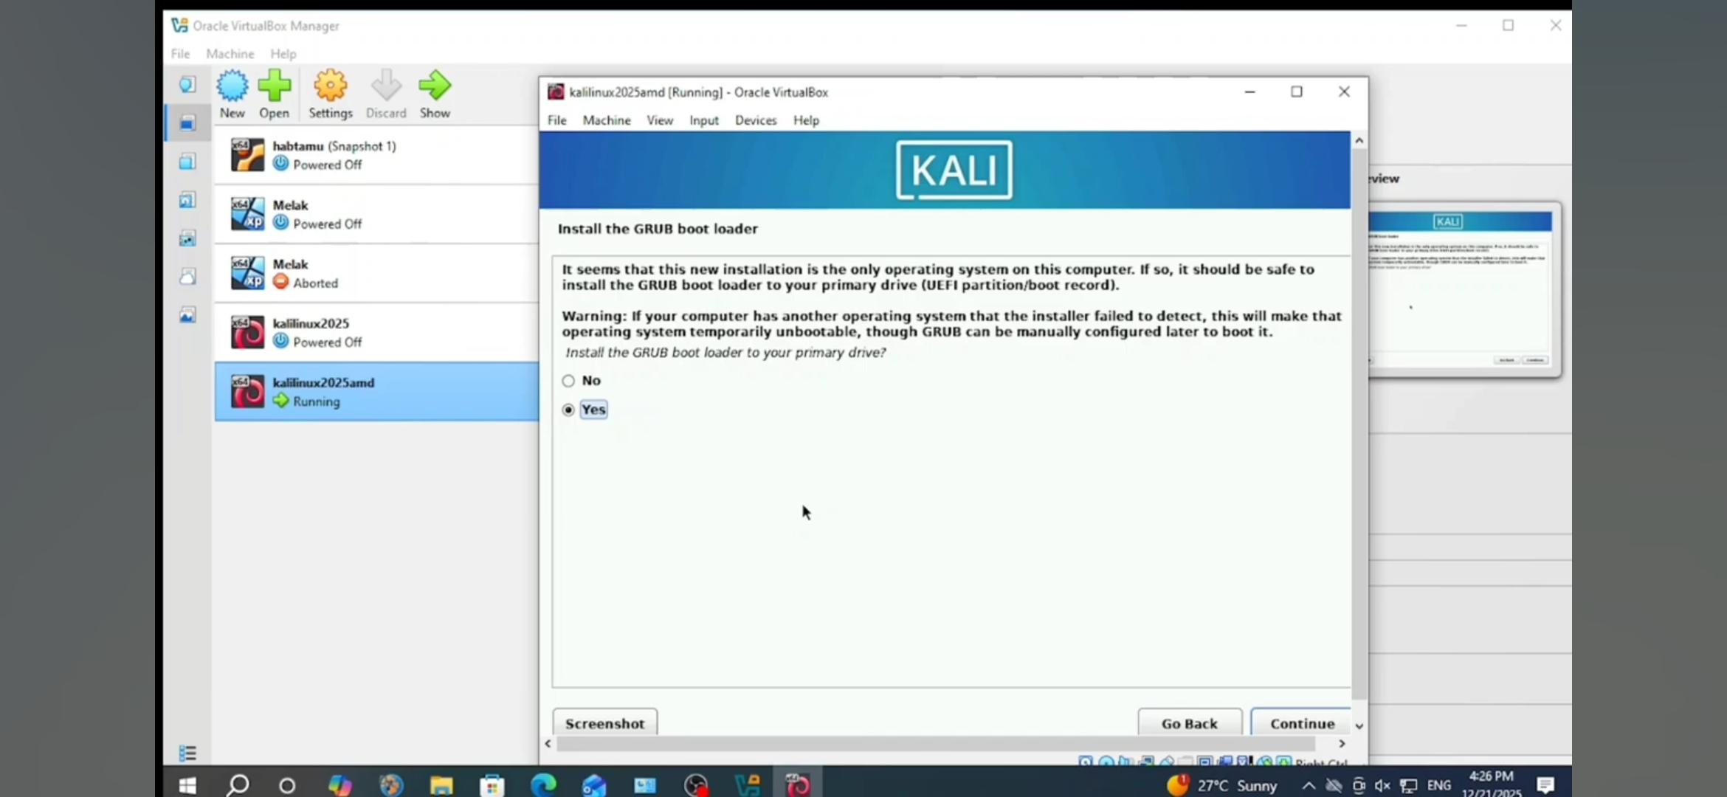
5. Complete installation and reboot the VM.
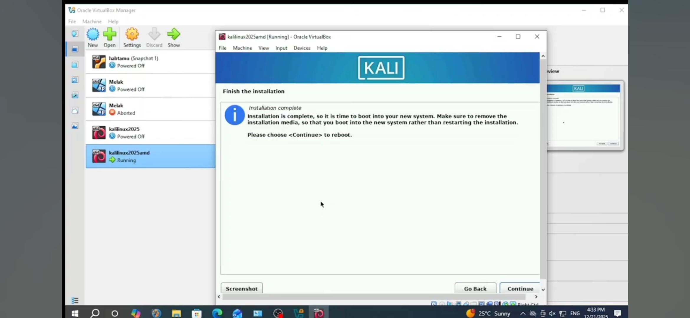Step 5: Post-Installation (Optional but Recommended)

- Update Kali: Open terminal and run `sudo apt update && sudo apt full-upgrade`.
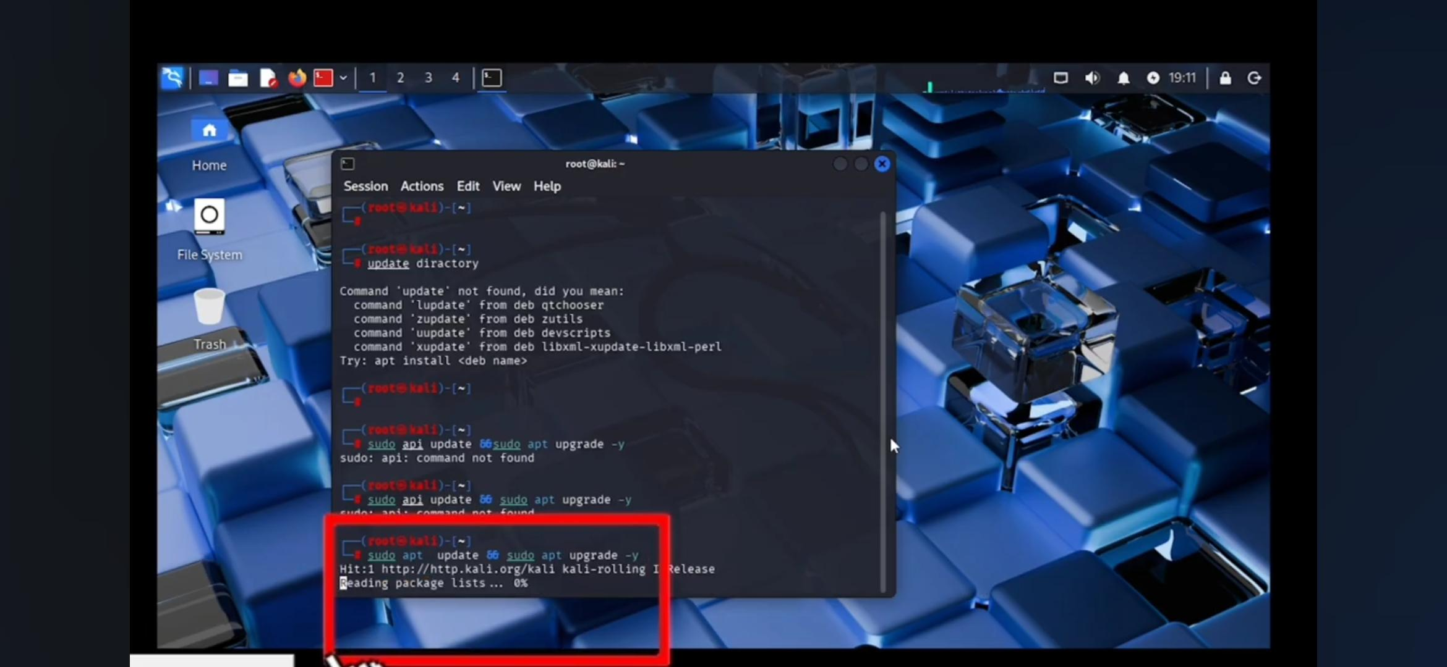

Conclusion
Kali Linux was successfully downloaded and prepared for installation on VirtualBox. This virtual setup provides an isolated environment for learning penetration testing tools safely.

.

